1. cd ..
2. cd .. (**NOTE:** the path should be <C:\> )
3. cd xampp
4. cd mysql
5. cd bin
6. mysql -u root -p (if has a root password)  
   mysql -u root(if no password)
7. 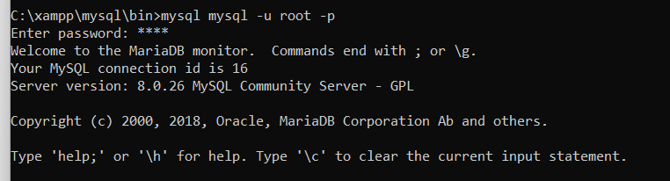
8. show databases;
9. CREATE DATABASE `php-tutorial`; (**NOTE**: it should be backticks not single quote, left side on your number 1 keys from laptop)
10. USE `php-tutorial`; (**Note:** if the message shows Database changed then you’re in the database now**)**
11. CREATE TABLE user_account(
12. name varchar(255) not null,
13. age int(255)not null); (**NOTE**: include the end of the parenthesis if you are done with the fields you need)
14. desc user_account;
15. INSERT INTO user_account(name,age) VALUES(
16. (‘Carlo’,25),
17. (‘John’,21);
18. 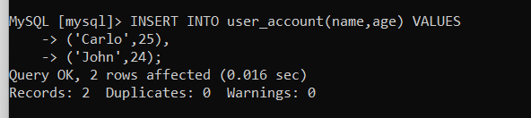
19. SELECT * from user_account
20. 